Advanced Database Training
2026
Vaishnavi Kamthe

Assignment 3b
1. Write a SQL query to list down the winning and closest losing candidate (runner-up) by constituency.
Note: if two candidates have the same number of votes then list down both the candidates. (for both winner or runner-up)
SELECT constituency_name,
firstname,
surname,
votes,
rank_position
FROM (
SELECT constituency_name,
firstname,
surname,
votes,
DENSE_RANK() OVER (
PARTITION BY constituency_name
ORDER BY votes DESC
) AS rank_position
FROM election
) t
WHERE rank_position IN (1, 2);
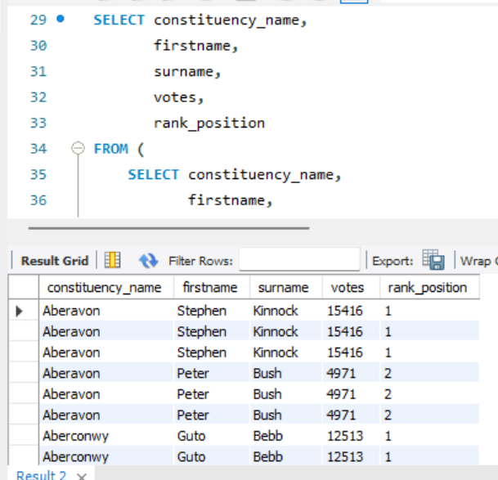
2. Write a sql query to find out the gender-wise percentage of winning candidates by country.
(Note: Winners are declared for each constituency)
WITH ranked AS (
SELECT constituency_name,
gender,
country_name,
DENSE_RANK() OVER (
PARTITION BY constituency_name
ORDER BY votes DESC
) AS rnk
FROM election
)
SELECT country_name,
gender,
ROUND(100 * COUNT(*) /
SUM(COUNT(*)) OVER (PARTITION BY country_name), 2) AS percentage
FROM ranked
WHERE rnk = 1
GROUP BY country_name, gender;
